How to Add $ to Invoice in Lacerte

- Open lacerte
- Select the client return

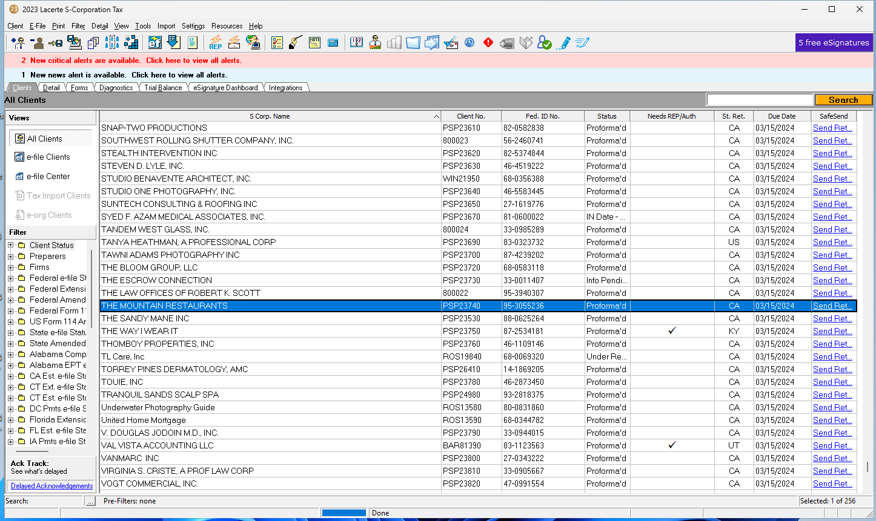

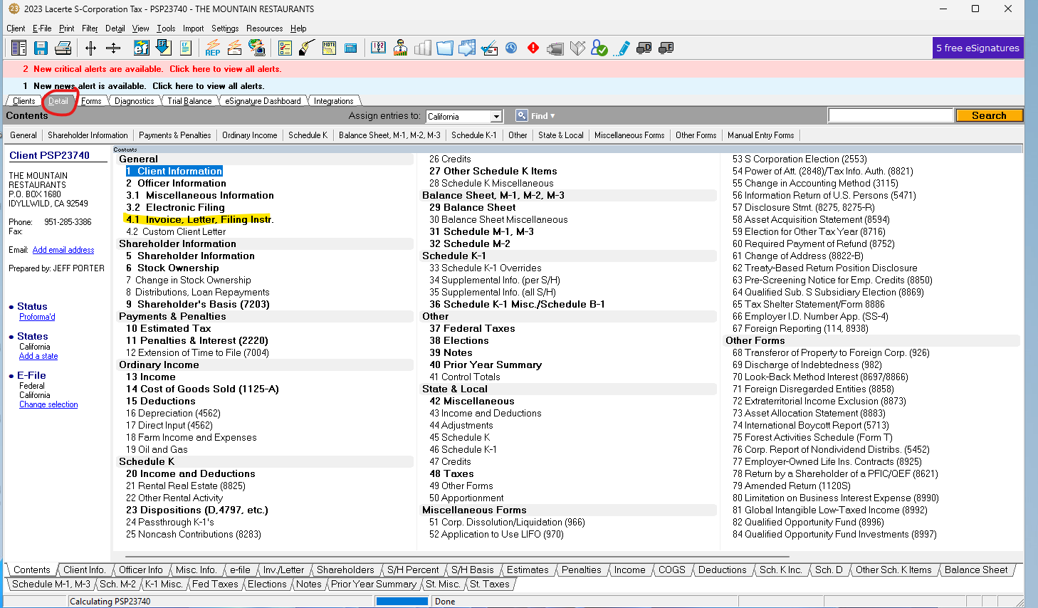
- Under the detail tab, there is a table of contents. Search for the invoice and click on it.
  - The invoice may be a different number on the table of contents depending on the return type.
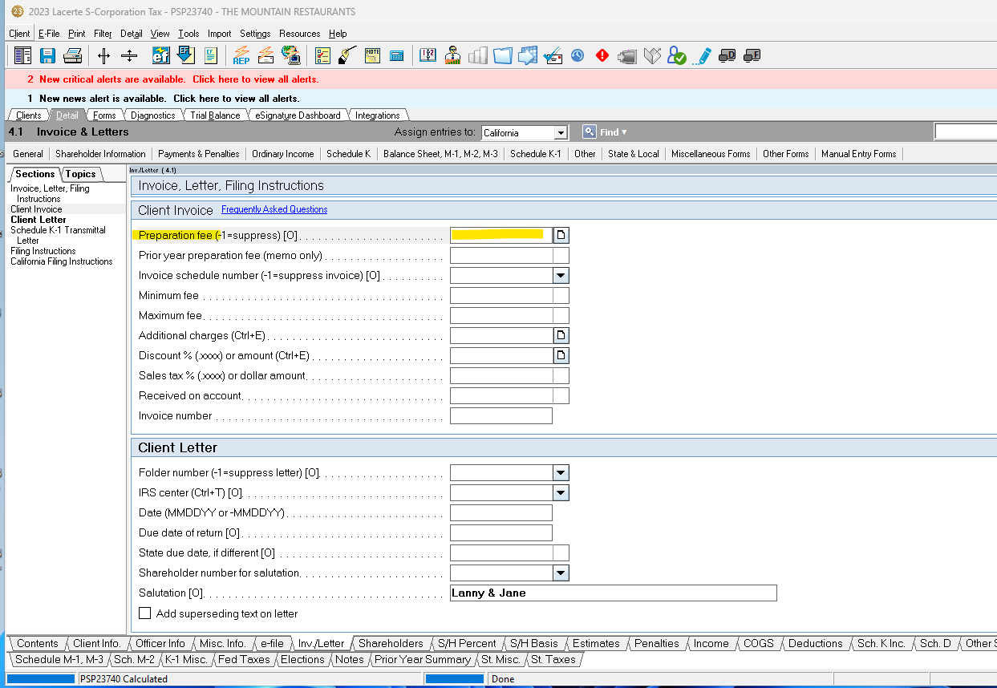

- Enter the preparation fee
- There is no save button, so once you enter a dollar amount it will auto save it

How to Add $ to Invoice in Ultra Tax

- Open ultra tax
- Select the client return and open it
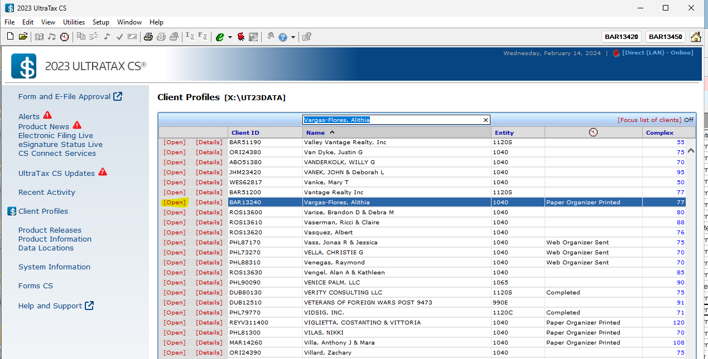

- Return automatically opens to federal portion, select Letter tab

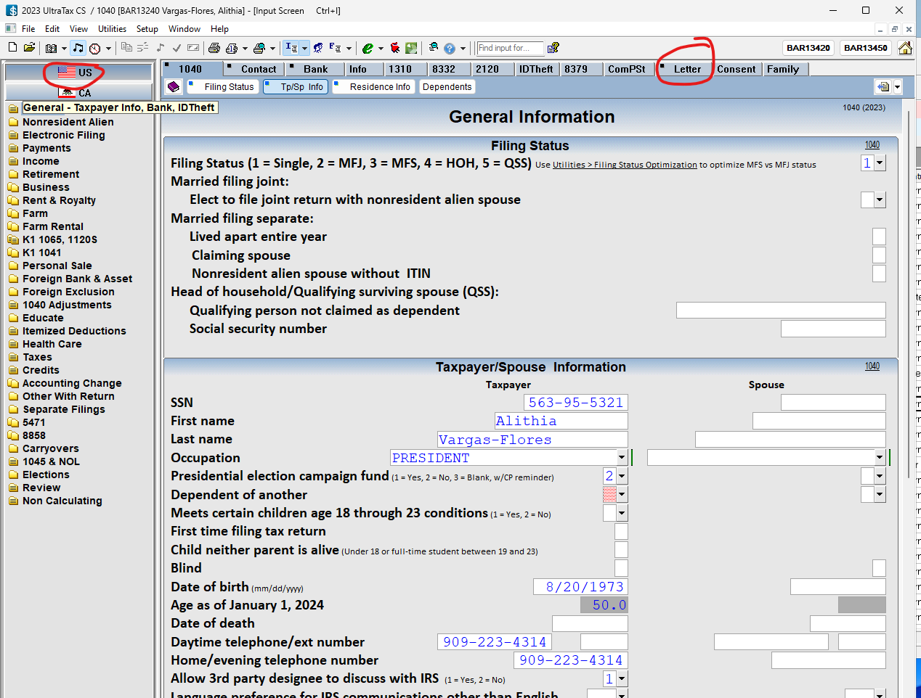

- Select invoices section, enter preparation fee
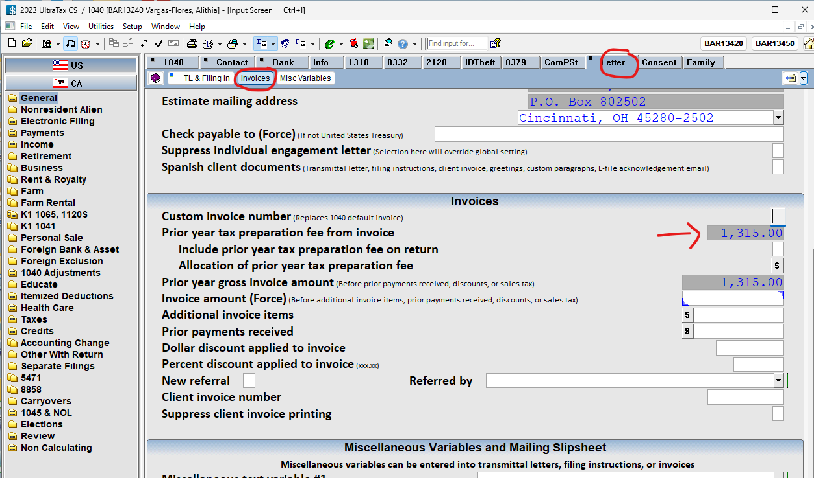

- There is no save button, so once you enter a dollar amount it will auto save it

